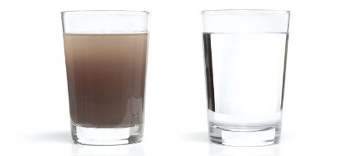
Water Pollution and Plant Life
This Photo by Unknown Author is licensed under CC BY-ND

We use water for everything in our daily life to help clean.
Create a brainstorm with some of the things that can be found in waste-water from your everyday life.

Your dirty water leaves your house through the drains but where does it go from there?
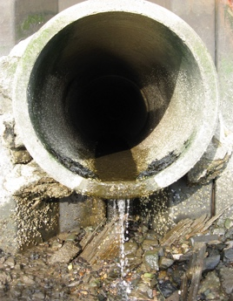
Generally, waste-water goes one of two different places:
This Photo by Unknown Author is licensed under CC BY
- Septic tank in the backyard
This means the water eventually seeps back into the ground and plants can use this to grow.
- Sent to a waste-water treatment plant through a sewer system
At a waste-water treatment plant the water is treated and ‘cleaned’ till it is 99% water and 1% other human items. This last 1% determines if humans can reuse the water or if it is considered harmful.

Water this is considered harmful is then pumped out into the ocean. The sewage pipes are located roughly 3km off-shore and 80m deep.

Do you think this is the best way to remove the water? Can you suggest any better alternatives?
____________________________________________________________________________________________________________________________________________________________________________________________________________________________________________________________________________________________________________

Do you think it would be a good idea to collect the waste-water from your house and water your garden?

___________________________________________________________________________

Investigating if ‘waste water’can be used to water plants

Aim: To investigate how water polluted by humans effects the growth of a plant.

Variables
Independent – Water contaminate
Dependent – Growth of plant

Hypothesis
___________________________________________________________________________
______________________________________________________________________________________________________________________________________________________

Materials:
- Radish seeds
- 3 foam cups
- Soil
- 3 different contaminated water
  - Recycled Laundry water
  - Recycled oil water
  - Tap water

Method:
- Plant the 3 seeds into the three cups.
- Water each plant with the same amount of water. Each plant should be watered with a different contaminant.
- Water the plants in each class for the next week.

Results:
Water Contaminant | Did the plant grow? | Observations

Discussion:

What plant grew the best?

Why do you think this plant may have grown the best?
____________________________________________________________________________________________________________________________________________________________________________________________________________________________________________________________________________________________________________
______________________________________________________________________________________________________________________________________________________

Did any of you plants not grow?

Why do you think they did not grow?
_________________________________________________________________________________________________________________________________________________________________________________________________________________________________
______________________________________________________________________________________________________________________________________________________

Do you think that we should collect our waste water and use it on our garden? Why?
____________________________________________________________________________________________________________________________________________________________________________________________________________________________________________________________________________________________________________

